The Evolution of AI Agents and Modern AI Engineering
Technical Research Report

1. LLM Applications: From Text Generators to Agents
Large language models (LLMs) first reached wide use as single-turn completion and chat applications: summarizers, chatbots, copywriting tools, and code assistants that took one prompt and returned one response. The next stage, retrieval-augmented generation (RAG), grounded answers in external documents by injecting retrieved text into the prompt. Both stages treat the LLM as a passive responder — it does not decide what to do next, observe outcomes, or use external tools on its own. AI agents are the next step in this progression: the LLM becomes the reasoning engine inside a loop that can call tools, remember state, and pursue multi-step goals with limited supervision.

2. AI Agents
An AI agent wraps an LLM in a perceive → plan → act → observe loop. Given a goal, the model reasons about the next step, takes an action (often a tool call), observes the result, updates its working memory, and repeats until the goal is met or a stopping condition is reached. This turns a stateless text predictor into a system capable of autonomous, multi-step task execution.
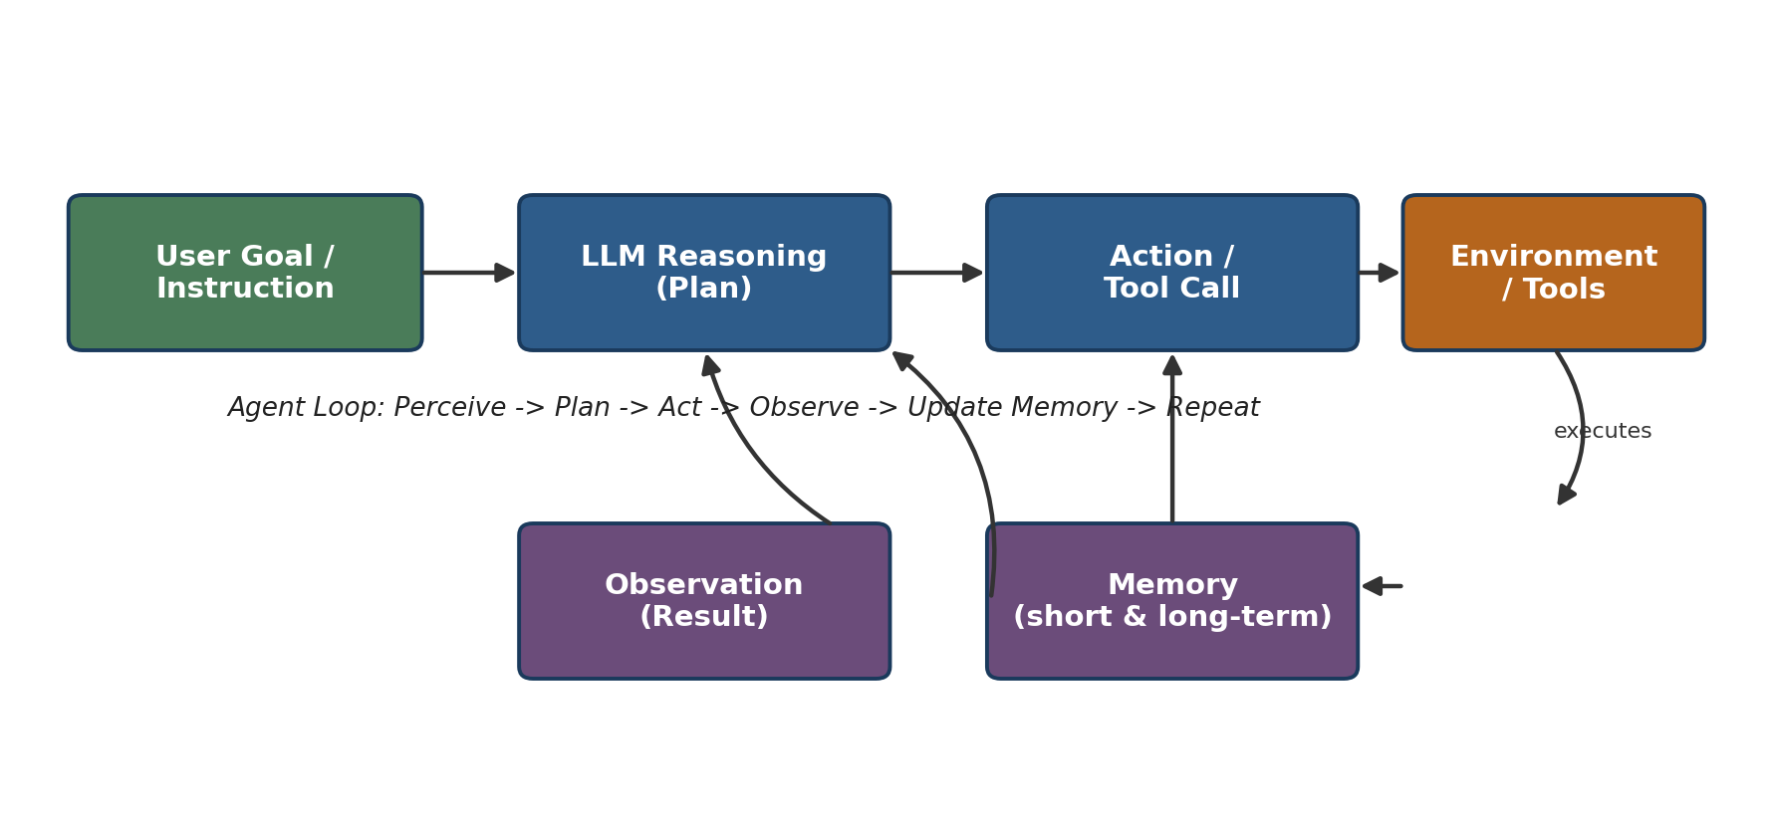
Figure 1. The core agent execution loop.
Real-world example: Claude Code and GitHub Copilot Workspace both run this loop to read a codebase, plan changes, edit files, run tests, and iterate on failures without a human in every step.

3. Tool Calling
Tool calling (also called function calling) lets a model invoke external functions — search, databases, code execution, APIs — through a structured schema instead of free text. The model outputs a JSON-like request naming the tool and its arguments; the application executes it and feeds the result back into context for the next reasoning step. The Model Context Protocol (MCP), introduced by Anthropic, standardizes how agents discover and call tools/data sources across vendors, similar to how USB standardized device connections.
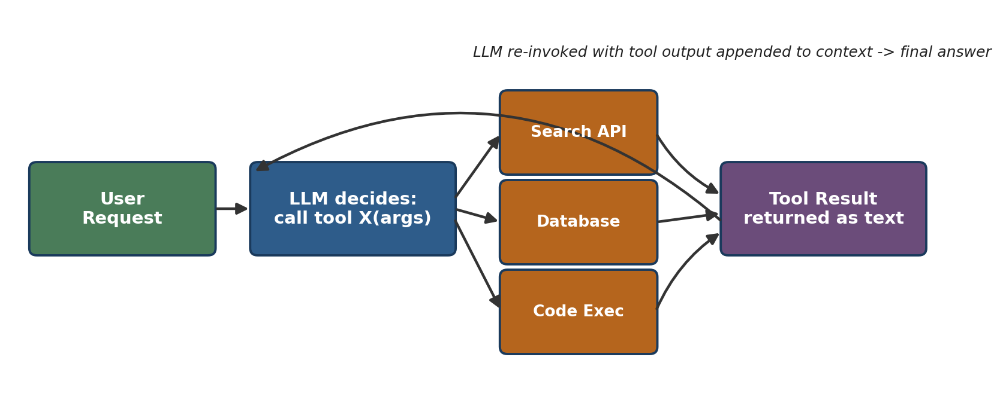
Figure 2. Tool-calling request/response cycle.
Real-world example: Customer-service agents (e.g., Klarna’s support assistant) call order-lookup and refund-processing tools; coding agents call shell and file-edit tools; research agents call web-search tools.

4. Memory
Agents need memory beyond the model's fixed context window:
- Short-term / working memory — the current conversation and scratchpad held in the context window.
- Long-term memory — facts, preferences, and past interactions stored in a vector database or key-value store and retrieved when relevant.
- Episodic memory — records of past tasks/trajectories used for reflection and self-improvement.
- Procedural memory — learned skills or reusable code/tool routines.
Real-world example: Persistent memory in ChatGPT and Claude carries user preferences across sessions; coding agents cache project conventions in a memory file to avoid re-deriving them each run.

5. Planning
Planning is how an agent decomposes a goal into executable steps and adapts when steps fail. Common patterns:
- Chain-of-Thought — the model reasons step-by-step before answering.
- ReAct (Reason + Act) — interleaves reasoning traces with tool actions and observations.
- Task decomposition — breaking a large goal into an ordered sub-task list, revised as new information arrives.
- Reflection / self-critique — the agent reviews its own output or failed attempts and revises its plan.
Real-world example: AutoGPT-style agents and Claude Agent SDK–based coding agents maintain an explicit task list, checking off items and re-planning after test failures.

6. Multi-Agent Systems
Complex workflows are increasingly split across specialized agents coordinated by a supervisor: a research agent gathers information, a coding agent implements, a reviewer checks quality, and a writer produces the final output. Frameworks such as LangGraph, CrewAI, Microsoft AutoGen/AG2, the OpenAI Agents SDK, Google's Agent Development Kit (ADK), and the Claude Agent SDK provide orchestration primitives — graphs, role-based crews, or conversational group chats — for this coordination. In 2026, LangGraph leads production deployments of stateful multi-agent workflows, while CrewAI is favored for fast, role-based prototyping, and AutoGen (now AG2) is best known for conversational, debate-style coordination [1][2][3].
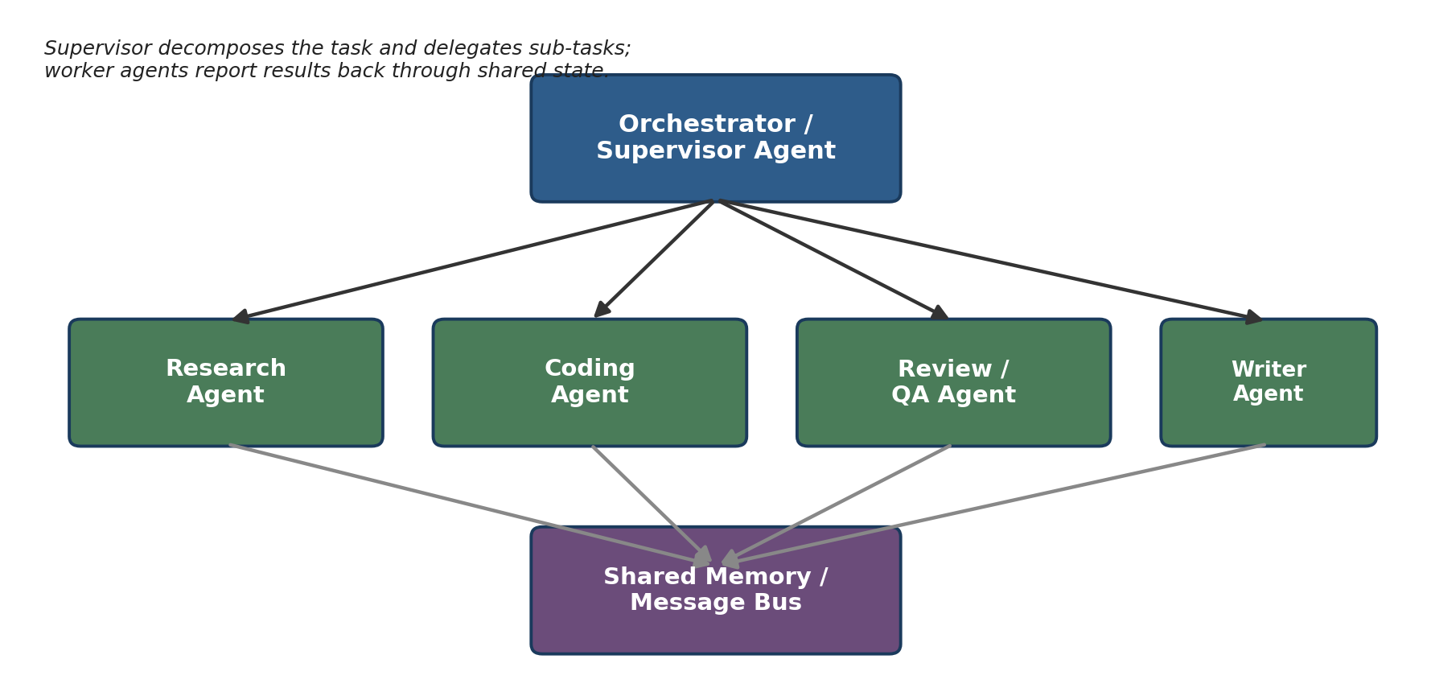
Figure 3. Orchestrator-worker multi-agent pattern with shared memory.
Real-world example: Anthropic's own multi-agent research system uses a lead agent to spawn parallel sub-agents that each explore part of a research question before results are synthesized [4].

7. Future of AI Engineering
- Standardized interoperability protocols (MCP for tools/data, Agent2Agent-style protocols for cross-framework agent communication) will let agents built on different stacks collaborate.
- Stronger observability and evaluation tooling (tracing, token/cost budgets, automated eval suites) is becoming as important as the agent logic itself.
- Long-horizon autonomy with human-in-the-loop checkpoints will replace fully autonomous or fully manual extremes for high-stakes tasks.
- Framework consolidation: a small number of production-grade orchestration frameworks and vendor-native SDKs are emerging as defaults, while custom orchestration remains common at the largest scale [1].
AI engineering is shifting from prompt-crafting toward systems engineering: designing reliable loops, memory architectures, guardrails, and evaluation pipelines around the model.

References
[1] Presenc AI, "Multi-Agent Orchestration Frameworks 2026," presenc.ai, May 2026.
[2] Alice Labs, "Best AI Agent Frameworks 2026," alicelabs.ai, 2026.
[3] OpenAgents, "CrewAI vs LangGraph vs AutoGen vs OpenAgents," openagents.org/blog, March 2026.
[4] Anthropic, "How we built our multi-agent research system," anthropic.com/engineering, 2025.
[5] Anthropic, "Introducing the Model Context Protocol," anthropic.com/news, November 2024.
[6] Yao, S. et al., "ReAct: Synergizing Reasoning and Acting in Language Models," ICLR 2023.

